**The practices and principles of good data stewardship**

As you have been learning, all data professionals are responsible for ensuring the quality, integrity, accessibility, and security of data. Data stewardship is the practice of ensuring that data is accessible, usable, and safe. Making data stewardship a normal part of your work habits will benefit everyone who relies on your analysis, both inside and outside of your organization. In this reading, you will learn more about data stewardship and receive some best practices that can assist in guiding your career in data analytics.

**Respect privacy**

Earlier in this course, you learned about Information that permits the identity of an individual to be inferred by either direct or indirect means. This kind of information is commonly referred to as personally identifiable information or PII. When users share personal information, they are putting a high level of trust into an organization. It is the responsibility of all who have access within the organization to help protect the privacy of their users. As a data analytics professional, it is important to be thoughtful about any personal data and exhibit great care to protect it. In different parts of the world, laws are in place to guide best practices for data privacy. Laws provide a foundation for best practices as you grow in knowledge and experience on how to support and sustain privacy. One of your responsibilities as a data professional will be to stay up to date with any change in data laws and regulations that govern data. Depending on your organization’s location or industry considerations, there may be additional regulations and policies in place. Here are a couple of regional examples:

* General Data Protection Regulation or [GDPR](https://gdpr.eu/) (European Union law):
  + The GDPR is described on their website as the toughest privacy and security law in the world. It imposes obligations onto organizations anywhere, so long as they target or collect data related to people in the European Union.
* Lei Geral de Proteção de Dados Pessoais or [LGPD](https://www.gov.br/cidadania/pt-br/acesso-a-informacao/lgpd) (Brazil’s general law for the protection of personal data):
  + The LGPD is a data protection law that governs how companies collect, use, disclose, and process personal data belonging to people in Brazil. LGPD applies to companies that process data about individuals in Brazil.
* The California Consumers Privacy Act or [CCPA](https://oag.ca.gov/privacy/ccpa) (Privacy rights for California consumers):
  + The CCPA gives consumers more control over the personal information that businesses collect about them. These regulations provide guidance on how to implement the law.
  + Additionally, states like Virginia, Colorado, New York, Utah, and Connecticut have enacted similar legislation to protect consumer privacy in their states.

**Be cautious of unintentional harm**

Data analytics is expanding its influence across an increasing range of industries. Companies are using the results of data analysis to make informed decisions. Many of these decisions have the potential to impact people across a broad range of social and economic factors. It is good practice to continually strive to produce information that is accurate, while respecting cultural and social norms.

Due to the global marketplace, decisions play out differently in different cultures. Taking these issues and considerations into account is very important for the executive team of an organization. Also, companies are known to take a position on particular politicized social and cultural issues, and these can be reflected in their policies. As a data analytics professional, you must be cognizant of your company’s policies. When presented with challenges, it is best to seek guidance from leadership within your organization on how to navigate.

**Avoid creating or reinforcing bias**

You have learned about bias within data and how it can have an impact on your analysis. Identifying bias is not always simple. A good practice when working with data is to keep in mind that data gathering is a task managed by humans–and that process is informed by people from different backgrounds, experiences, beliefs, and worldviews. These and other types of biases can affect the data and the results, which in turn can have an impact on business decisions. You will learn more about bias within data as you progress through the program.

**Consider inclusivity**

Often in your role as a data analytics professional, you will have access to data collected in a variety of ways. You will need to consider whether the methods of data collection have excluded information from particular populations. Inclusionary approaches can expand how any organization collects and analyzes data. Building diverse research teams, communicating clearly with user communities, and engaging in careful and critical analysis that considers equity and inclusion benefits all stakeholders.

**Uphold high standards of scientific excellence**

The processes and technology that you will interact with as a data analytics professional are deeply rooted in the scientific method. As you continue in your data professional journey, embrace inquiry, intellectual discussion, and collaboration. Invite feedback and assess feedback. Remember, artificial intelligence still depends heavily on the instructions provided by data professionals. The more time and consideration that goes into the process of data analytics, the better the results.

Different industries have different standards. In your role as a data analytical professional, you will need to be aware of the standards for the industries you are working in. Each industry will have its own standards based on industry conventions.

Conventions that work well in the transportation industry may not necessarily be as high of a priority for the healthcare industry. For example, in transportation, data is collected to create predictive analytics models to analyze the best route based on traffic patterns. In the healthcare industry, data is analyzed in medical imaging, predicting genetic factors, and speeding up the development of treatments.

**Data stewardship and ethics conversations**

As you progress through your career as a data analytics professional, you will need to consider issues of ethical concern. For example, you may encounter situations where you address questions of bias or need to protect user data and personally identifiable information (PII). When these types of questions arise, many seek guidance and support from online communities of data professionals who have dealt with similar issues. The following graphics present scenarios involving these kinds of issues. You can also find text alternative versions of these conversations in the [Data stewardship and ethics conversations transcript.](https://docs.google.com/document/d/1REAcRzABhtysbB4Nt8h7Gyqu3Sjv4cLfNC-7ETzauSg/template/preview)

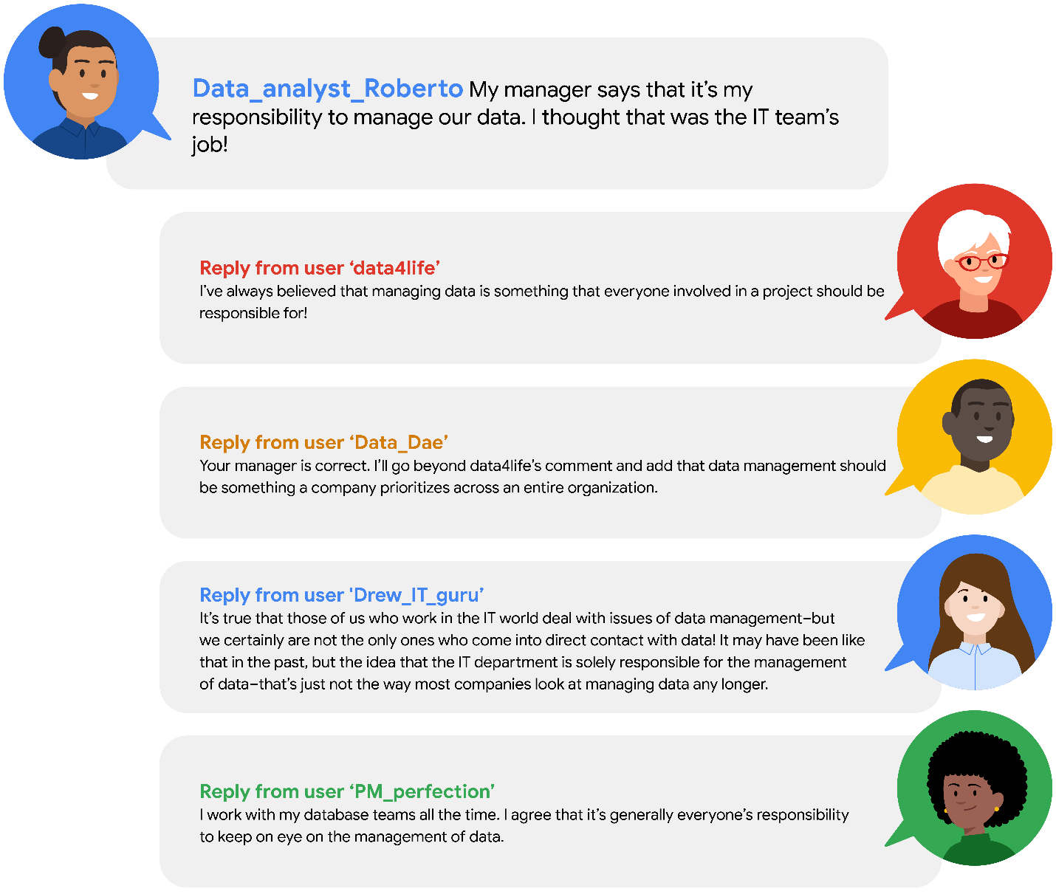

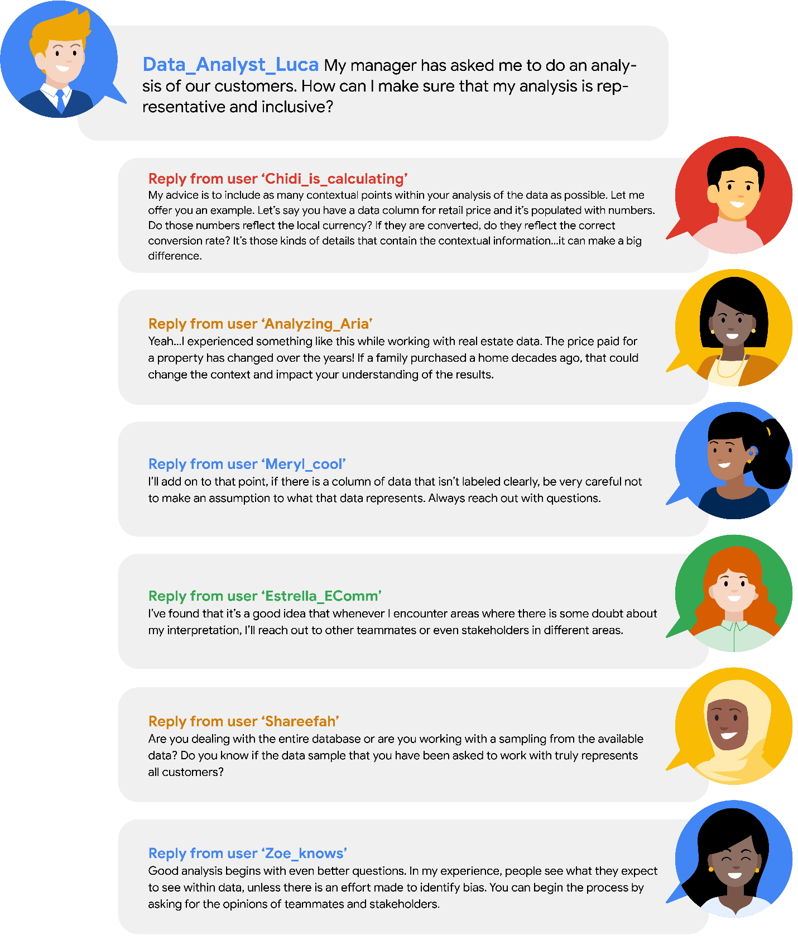

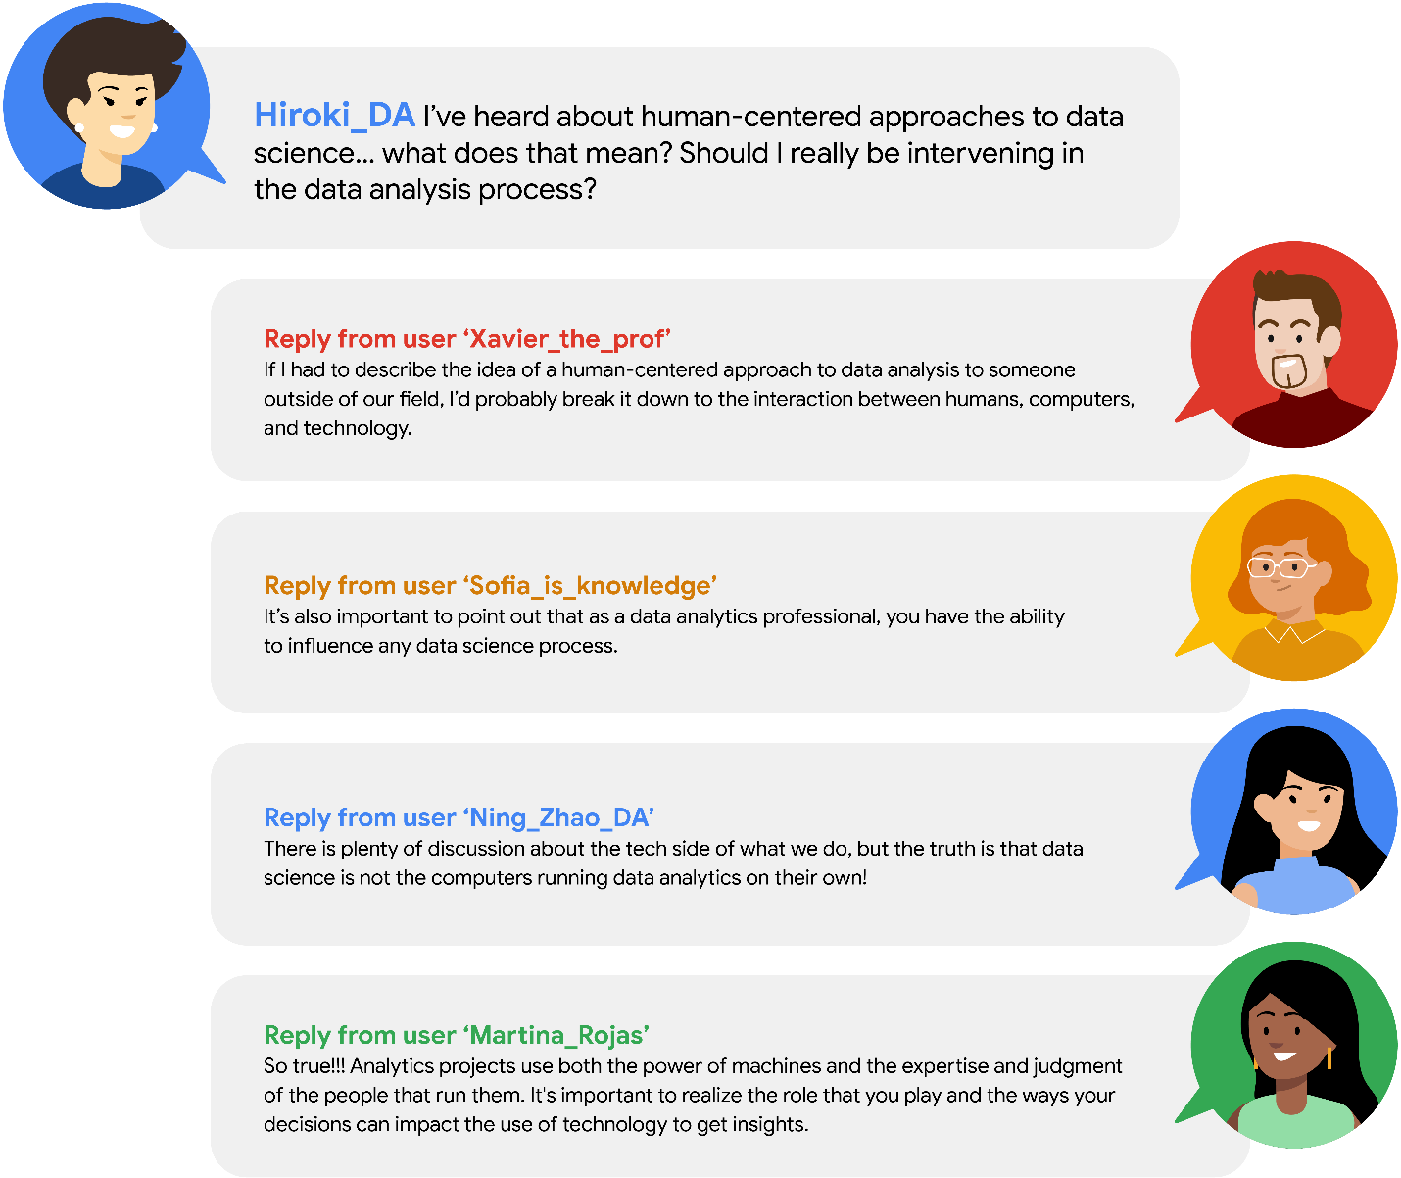

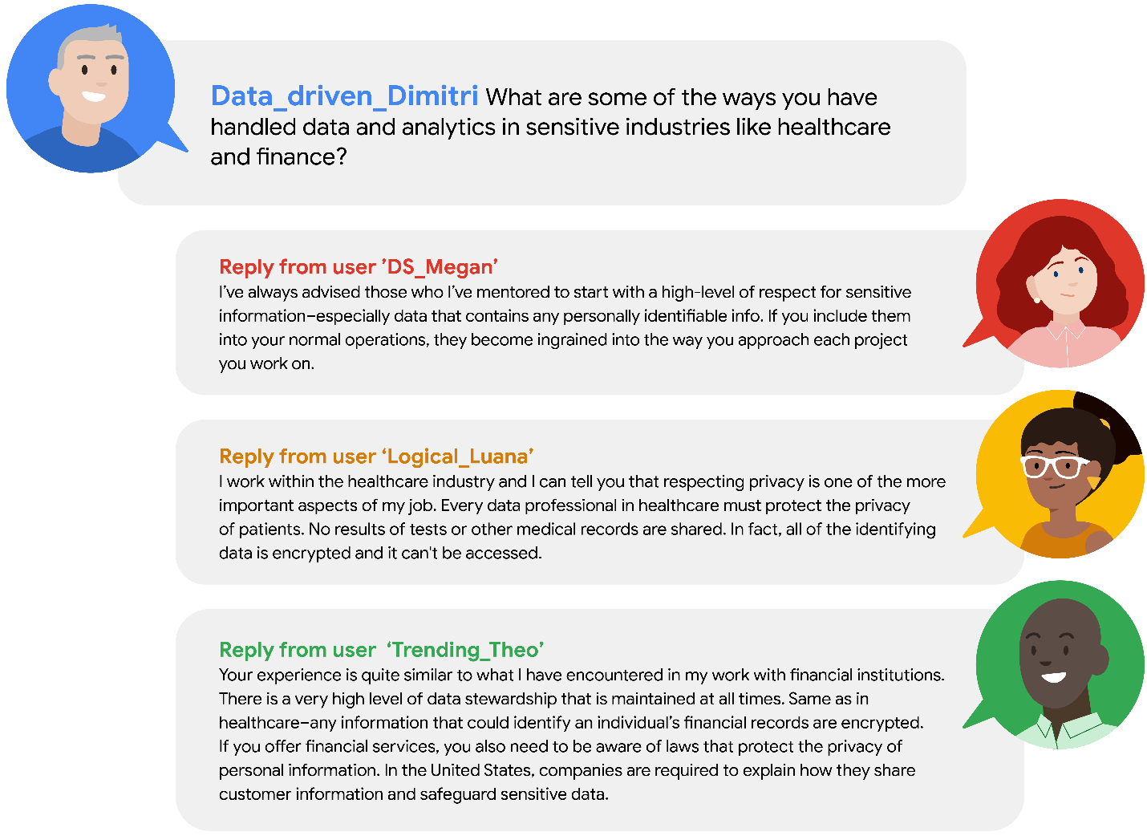

**Key takeaways**

Data stewardship is the responsibility of every data professional. This responsibility goes beyond interactions with the data. By conducting your work in ways that are socially beneficial and inclusive, you will increase your ability to identify human bias. Guide your efforts through scientific and ethical principles and stay aware of possible bias throughout the data analysis process.

Mark as completed

Like

Dislike

Report an issue